Flat Wire Machine – .Net Applications

Search Customers: Existing B2B dropdown needs to be renamed as "Type". It should contain "Regular Orders", "B2B" and "Flat Wire". As how the field turns green when B2B is selected, likewise it should turn pink when "Flat Wire" is selected. Orders of selected type should only be shown.
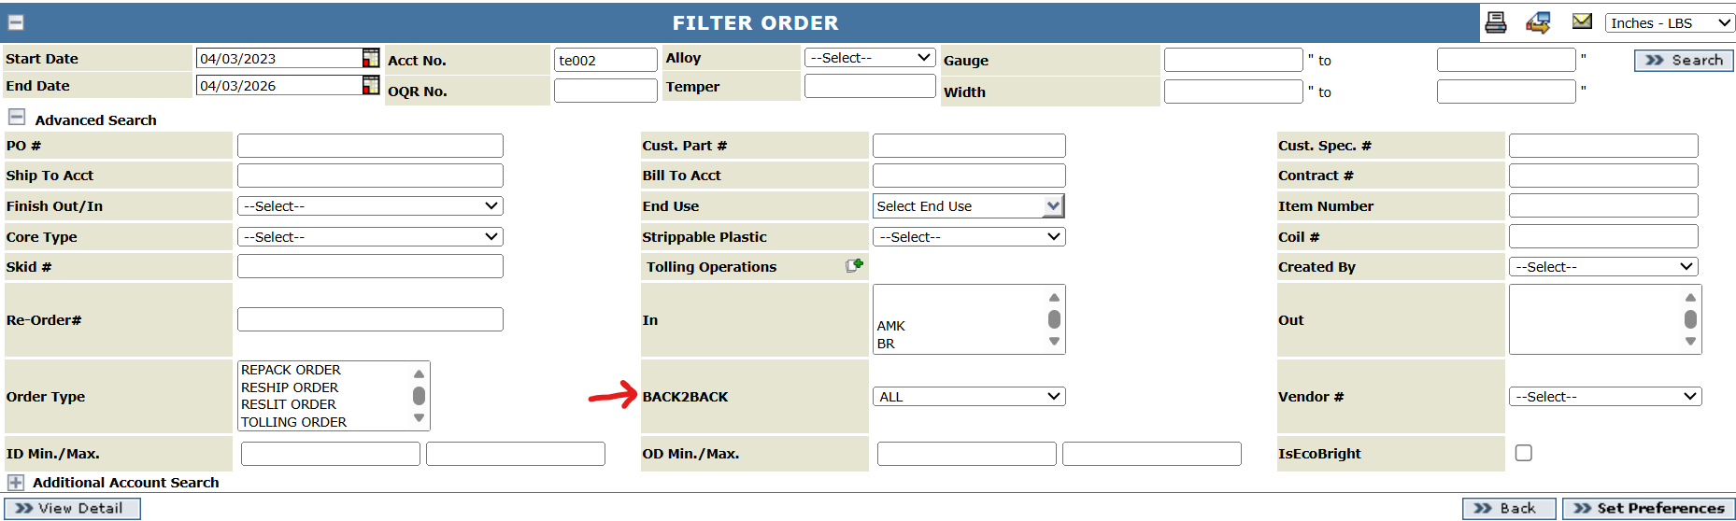

Order and Quotes screens:
Add a checkbox called "Flat Wire".
When "Flat Wire" checkbox is selected, a new field called "Bundle Width" will be shown, which would two textboxes, to show a range of values Min and Max. Bundle Width (both Min and Max) are mandatory, if "Flat Wire" checkbox is selected.
Add a new field called "Edge Type" with a dropdown shown. To start with, dropdown will contain values Round Edge and Flat Edge.
Auto-population of pricing fields will be determined later on, when more information is available.

Should the finish be open for users to change? Or should it be fixed same like B2B? Tim – I would leave it fixed for now as we do not have different rolls to change or affect finish. 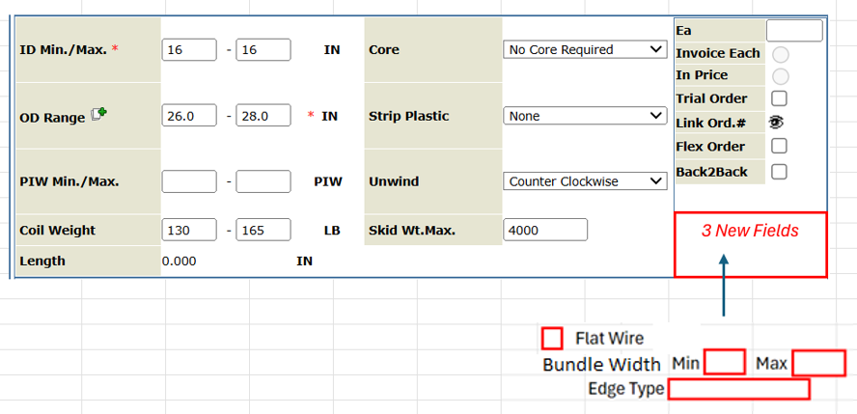
Tim – updated bundle id to bundle width in screen shot.

IQR/Item:
Add a checkbox called "Flat Wire".
Add new field called "Bundle Width", which would be a range of values Min and Max. Bundle Width (both Min and Max) are mandatory, if "Flat Wire" checkbox is selected.
Add a new field called "Edge Type" with a dropdown shown. To start with, dropdown will contain values Round Edge and Flat Edge.
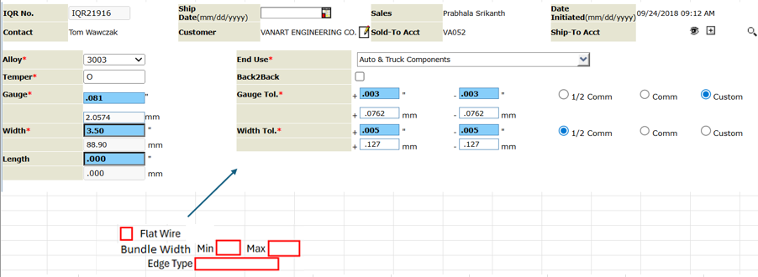

Tim – updated bundle id to bundle width in screen shot.

In Part & Product Details tab, automatically set the "Edge" critical attribute in Part & Product Details to "5 - Edge not a consideration" because this is slit related and does not apply to flat wire.

Should the finish be open for users to change? Or should it be fixed same like B2B? Tim – I would leave it fixed for now as we do not have different rolls to change or affect finish.

Item Template – SMP Creation:
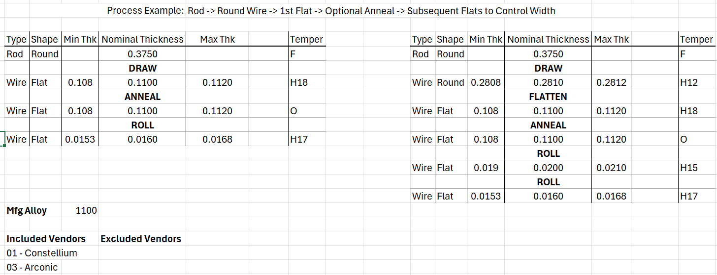

Account Maintenance: No changes.

Vendor Maintenance: Add a checkbox called “Flat Wire” to indicate that the vendor can supply flat wire product. This should be between Reroll and Scrap checkboxes.

Scrap Sales: WIP

CFRs: No changes.

Samples Report: No changes.

Certs: No changes.

